**Submission Form**

**Fill up the following slots with appropriate content. You must submit the content of this document from this page only.**

1. Your Name: Shihab Muhtasim
2. Your ID: 21301610
3. Your Section: 8
4. Experiment No: 3
5. Experiment Title: **To verify the value of vacuum permittivity by a parallel plate capacitor.**
6. **You must write your ID in each of the graphs you insert here.**
7. **Data Table 1**:

$A = 350 mm^{2}$

| **Sl:** | **Separation between plates, d (mm)** | **Capacitance, C**  **(pF)** |
| --- | --- | --- |
| 1. | 2 | 1.55 |
| 2. | 2.6 | 1.19 |
| 3. | 3.2 | 0.97 |
| 4 | 3.8 | 0.82 |
| 5 | 4.4 | 0.70 |
| 6. | 5 | 0.62 |
| 7. | 5.6 | 0.55 |
| 8. | 6.2 | 0.50 |
| 9. | 6.8 | 0.46 |
| 10 | 7.4 | 0.42 |

**8. Data Table 2:**

$d = 5 mm^{}$

| **Sl:** | ***Area, A***  ***( $mm^{2}$)*** | **Capacitance, C**  **(pF)** |
| --- | --- | --- |
| 1. | 100 | 0.18 |
| 2. | 120 | 0.21 |
| 3. | 140 | 0.25 |
| 4 | 160 | 0.28 |
| 5 | 180 | 0.32 |
| 6. | 200 | 0.35 |
| 7. | 220 | 0.39 |
| 8. | 240 | 0.42 |
| 9. | 260 | 0.46 |
| 10 | 280 | 0.50 |

9. Draw C vs 1/d graph for Data Table 1 and, that is, you plot 1/d along the x-axis

and C along the y-axis. You will get a straight line. You must take the best fit. (Check the lab channel for posts concerning how to take best if you don’t know what it means.) You must label the axes and write your ID in the graph. Insert **graph-1** here:

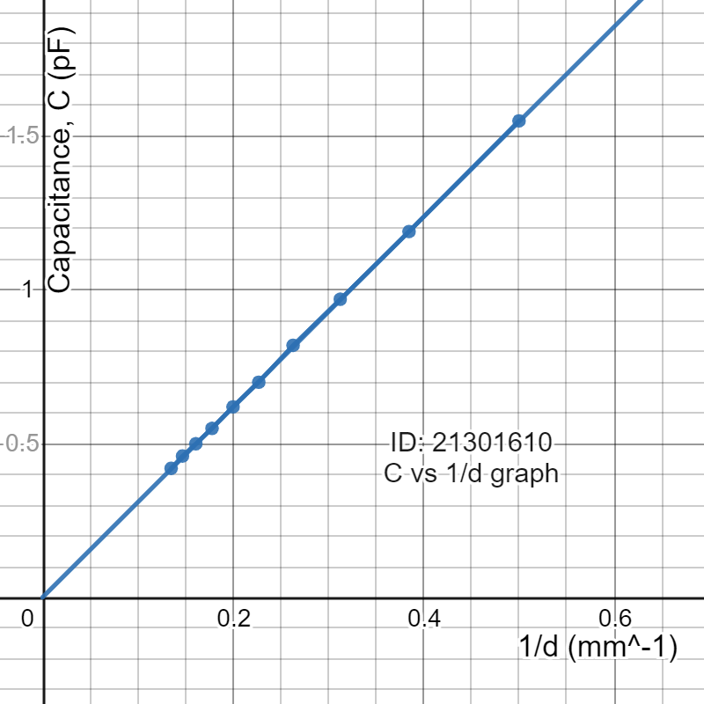

10. Draw C vs A graph for Data Table 2 and, that is you plot A along the x-axis and C along the y-axis. You will get a straight line. You must take the best fit. You must label the axes and write your ID in the graph. Insert **graph-2** here:

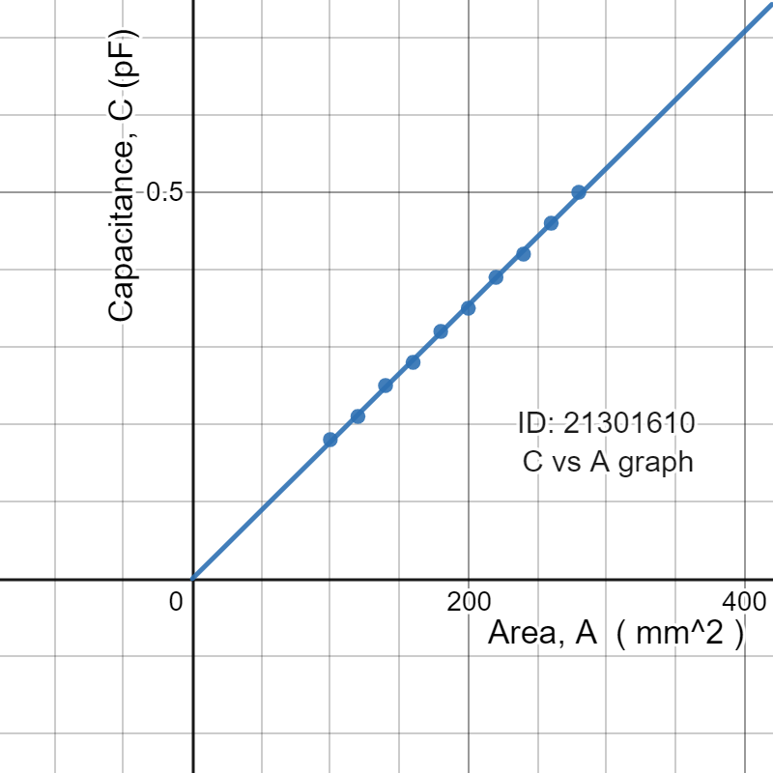

11. For Graph 1,

Slope = 3.09508 $\frac{pF}{{mm^{-1}}^{}}$

Calculated value of vacuum permittivity, = $8.8430*10^{-12} C^{2}N^{-1}m^{-2}$

[ Hint: capacitance of a parallel plate capacitor]

12. For Graph 2,

Slope =0.0017697 $\frac{pF}{{mm^{2}}^{}}$

Calculated value of vacuum permittivity, =

13. From the calculated value of vacuum permittivity from 11 & 12, we calculate the mean.

Mean vacuum permittivity = $8.84575*10^{-12} C^{2}N^{-1}m^{-2}$

**Comparing the calculated mean vacuum permittivity with the with the standard value of vacuum permittivity, ε_0 = $8.854 ×10{}^{-12}$ ${C^{2}N^{-1}m^{-2}}^{}$, we calculate the percentage of error.**

Percentage of error = [Calculated mean vacuum permittivity - Standard vacuum permittivity /Standard vacuum permittivity] * 100

= -0.09317 %

You are ***strongly*** encouraged to use your **own words** to describe your thoughts for the following part. **However, any kind of plagiarism (such as copying and pasting from other students’ lab-reports) will not be tolerated and will be subject to disciplinary action according to BracU policy.**

Please briefly answer the following question(s):

14. If we place a dielectric material of dielectric constant, κ<1 in place of air in between the plates of a parallel plate capacitor then what should be the change in graph-2 (C vs A graph for Graph 2)? Explain.

You must sketch by hand/ plot using a software, a diagram in your answer to help you compare both the cases.

Answer to the following question:

In our graph 2 , the dielectric constant κ, was 1 since we had air as our dielectric material. But if we placed a dielectric material of dielectric constant, κ<1 in place of air in between the plates of a parallel plate capacitor then the capacitance of the parallel plates would decrease. As we know that, C=k* Co so k is proportional to the capacitance and so is the area of the parallel plates. So the capacitance decreases for each value of A in Table-2 compared to when k was equals to 1. So in such a case the gradient of the Graph 2 will decrease in comparison to our previous value of k.

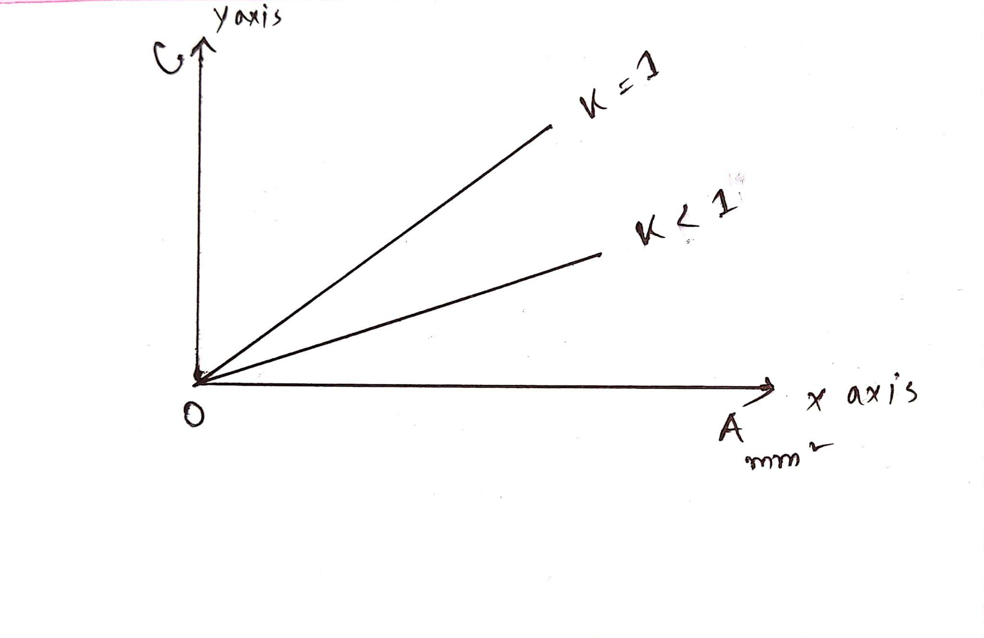

15. If half of the space between the plates are filled with a dielectric material of dielectric constant κ_1 and rest of the half space is filled with a dielectric material of dielectric constant κ_2, then

1. Find the equivalent dielectric constant.
2. Find the capacitance of this configuration.
3. If κ_1 = 2 κ_2, calculate the total stored energy in the capacitor.
4. Following the conditions and answers found for 3 , calculate the percentage of energy stored in the space of the capacitor filled with the dielectric constant κ_2.

